CompTia A+
A+ - Understanding and maintenance of Networks

Assignment-4
Day 4: Network Cable Types and ToolsTheory (30 min):Types of cables (Ethernet, fiber optics) and tools (RJ45 crimper).Practical (30 min):Create a straight-through Ethernet cable
QUE-01 List 3 key differences between Ethernet cables and fiber optic cables, and give one real-world example where each type would be used (for example, home WiFi router, data center, college campus backbone).
ANS
Differences Between Ethernet Cables and Fiber Optic Cables
Basis | Ethernet Cable | Fiber Optic Cable
1. Data Transmission | Transmits data using electrical signals through copper wires. | Transmits data using light signals through optical fibers.
2. Speed and Distance | Generally suitable for short distances, commonly up to 100 meters for standard twisted-pair Ethernet. | Supports very high speeds and much longer distances, depending on the fiber type and equipment.
3. Cost and Installation | Usually cheaper and easier to install for short connections. | Often more expensive to install and may require specialized equipment.
Real-World Example | Connecting a home Wi-Fi router to a desktop PC or gaming console. | Connecting buildings across a college campus or linking servers in a data center.

QUE-02 Draw and label a diagram showing the internal wiring of a straight-through Ethernet cable (use T568B wiring standard), indicating the color of each wire and its pin number.
ANS
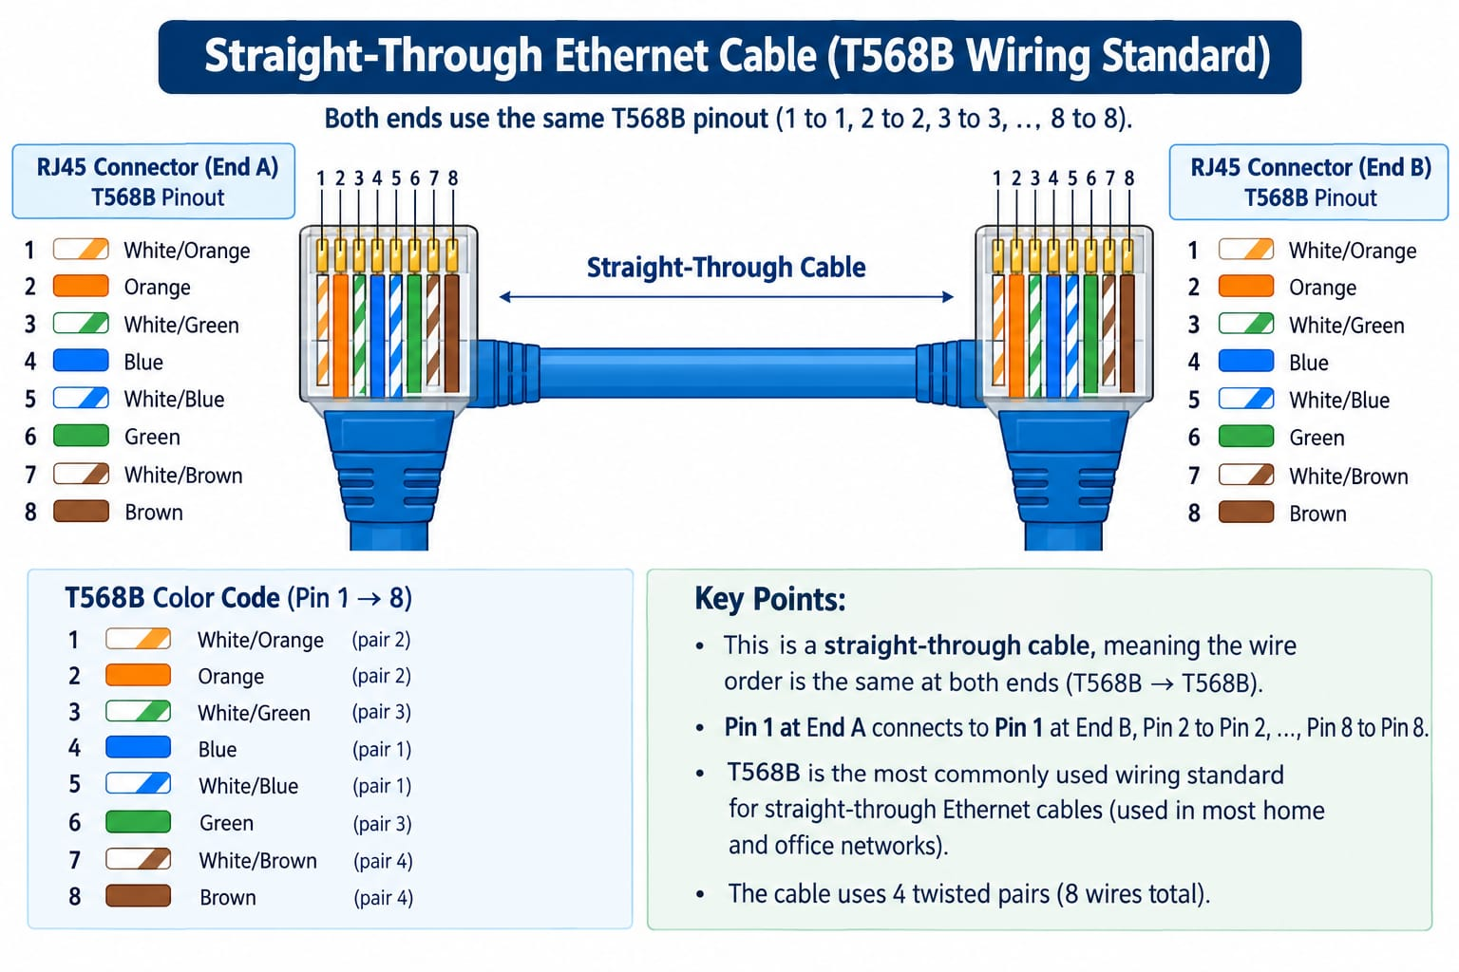
QUE-03 Watch a YouTube video demonstrating how to use an RJ45 crimper, then write a step-by-step guide (in your own words) on how to attach an RJ45 connector to a CAT6 cable.
ANS
Tools required
- CAT6 Ethernet cable
- RJ45 connector compatible with CAT6 cable
- RJ45 crimping tool
- Cable stripper or wire cutter
- LAN cable tester
Procedure
- Cut the cable: Measure the required length and cut the CAT6 cable neatly using a cable cutter.
- Strip the outer jacket: Remove approximately 2–3 cm of the outer insulation without damaging the eight internal wires.
- Separate the wires: Carefully untwist the four wire pairs and straighten the individual wires. Keep the untwisted section as short as possible.
- Arrange the wires: Follow the T568B wiring standard in the exact order shown below.
Pin | Wire colour
1 | White-Orange
2 | Orange
3 | White-Green
4 | Blue
5 | White-Blue
6 | Green
7 | White-Brown
8 | Brown
- Trim the wires: Hold all eight wires in order and cut their ends evenly so they fit inside the connector.
- Insert into the RJ45 connector: Slide the wires into the connector, ensuring each wire reaches the front and remains in the correct position. Make sure the cable jacket extends into the connector's strain-relief area.
- Crimp the connector: Place the RJ45 plug into the appropriate slot of the crimping tool and squeeze the handles firmly to secure the metal contacts.
- Repeat for the other end: For a straight-through Ethernet cable, use the same T568B wiring order on both ends.
- Test the cable: Connect both ends to a LAN cable tester. Check that all eight pins connect correctly and in sequence.
Precautions
- Do not mix up the wire colours.
- Avoid damaging the insulation of the internal wires.
- Use RJ45 connectors designed for your particular CAT6 cable type.
- Always test the cable before using it in a network.
Result: A properly crimped CAT6 straight-through Ethernet cable that can connect devices such as a computer, router or network switch.

QUE-04 Imagine you are setting up a gaming café with 10 PCs for LAN gaming. Decide which cable type (Ethernet or fiber optics) and which tool (RJ45 crimper or fiber cleaver) you would use, and explain your choices in 3-4 sentences.<br><br><em><strong>Hint:</strong> Consider speed, distance, and budget for your answer.</em>
ANS
For setting up a gaming café with 10 PCs, I would choose Ethernet CAT6 cables because they provide fast, reliable, low-latency connections for LAN gaming at an affordable cost. Ethernet cables are suitable for short distances, typically up to 100 metres for standard Ethernet links. I would use an RJ45 crimper to attach RJ45 connectors to the cable ends and connect the PCs to a network switch. Fiber-optic cables and a fiber cleaver would be more suitable for longer-distance connections, such as linking separate buildings

